
Intact Market Research India Pvt. Ltd.
D-2, 3rd Floor, Yadav Nagar,
Railway road Near Samaypur Badli Metro Station– 110042

Mob: +91-9999988532/9871155332

URL:www.intactresearch.com
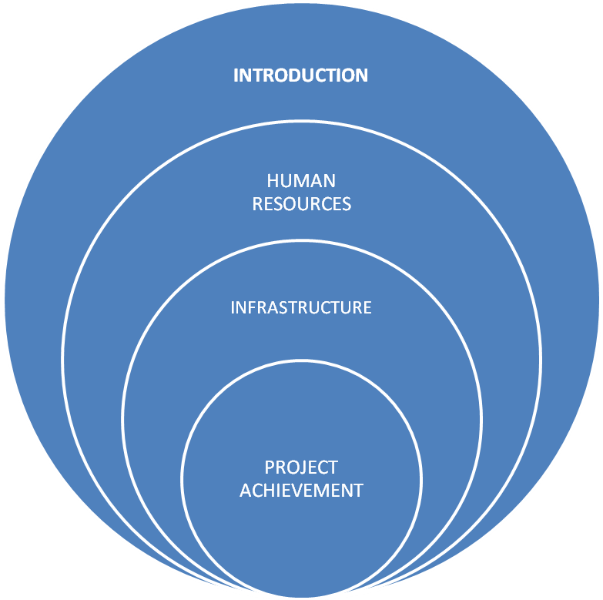

INTRODUCTION

Intact Market Research India Pvt Ltd., one of the fastest growing Road Research and Field Operation Company in India based in New Delhi. We express our deep interest to work for your esteemed organization.

We are having manpower resources in all metros and major cities in the country to cater all kinds of large sample size surveys for Roads and Traffic research projects.
Established in the year 2005, our company has been working with utmost dedication and helping our clients to successfully create fact based decisions by delivering intensive research based analysis reports. We offer many services including research based studies, qualitative research, and quantitative research. We have an extensive facility of data processing & analysis which is well developed and supports our company in different fields to offer comprehensive results at competitive prices for our clients. Apart from our standardized research services, we also offer customized research facilities in any field as per the need of our clients to make it smooth for them. With consistent excellence, we’ve have been meeting the diverse research based demands of our clients and this all is due to our valuable industry experience combining with the well defined operations based on innovative techniques. The services we offer includes Research Based Studies, Road and Traffic Research, Rural Development Studies, Qualitative Research, Tele Research Services, Quantitative Research, Mapping Studies, GIS Services, Remote Sensing Services, Agricultural Studies Services, Social Research Services, Industrial Research Services, Consumer Research Services, Market & Business Research Services, Advertising Research Services, Rural Research Services, Socio Economic Studies, Health Sector Studies.
All our business operations are handled by our Directors, Mr. Jasbir Singh and Mr. Kailash Arya driven by the visionary business approach of our Directors. Our Company has gained recognition as a leading organization in the field of market research, business research, Internet-based research, Internet media analysis (IMA), forms processing, database management, market surveys, secondary & primary data collection, document scanning, mailing list development, data cleansing as well as checking.

INTACT MARKET RESEARCH INDIA PVT LTD.: - Operations strive hard to deliver the highest possible level of customer care, the best value for money and the most appropriate solution – all backs by the drive, innovative imagination and resourcefulness that make to become an esteem firm in Road Survey, Design and Traffic fields.
At present firm is operating in the following areas and aim provide satisfactory solution in these areas.

We at INTACT MARKET RESEARCH INDIA PVT LTD. offer comprehensive consultancy services in:-

Traffic surveys

Classified Traffic volume counts (T.V.C.)
- VVD Survey (24 Hours)

- Origin Destination (O.D.) surveys.

- Intersection count

- Speed & Delay

- Willingness to pay

- Road Network Inventory

- Axle load surveys.

- Household Surveys.

- Mid Block & Intersection Pedestrian Surveys.
- Roadside activities.

- Total station surveys.

- Land use surveys.

- Lux Surveys.

- Interchange Surveys.

- Speed & Delay (passenger’s vehicle and transport vehicles).

- Light phase intersection surveys.

- Urban planning.

- Rural Planning.

- Designing of Roads, Flyovers, Bridge & Metro, Railway Tracks

- Construction of roads, metros and railways.

- Comprehensive mobility plan projects for urban and rural areas

- On street and off street Parking Surveys.

- IPT Surveys.

- Toll Surveys.

- Soil Testing Surveys.

- Water Resources Surveys.

HUMAN RESOURCES

We are a team of experienced and qualified personnel whose prime concern is delivering best possible design solutions. The team members are as under:
1. Harish Arya – Director
He has about Twenty years’ experience in various Road Survey, Design and Traffic projects as well as Traffic surveys and Topographical surveys & also we are deal in data collection in Market Research Study.
2. Kailash Arya – Managing Director
He has about Twelve years’ experience in various Road Survey, Design and Traffic projects and Traffic surveys and Topographical surveys & also we are deal in data collection in Market Research Study.

3. Sanjeev Joshi – Operations Head (Traffic Division)
He has about Twelve years’ experience in various Road Survey, Design and Traffic projects and Traffic surveys and Topographical surveys. He has also experience of comprehensive mobility plan for urban and rural also, He has done such exercise for Ludhiana, Delhi and Jaipur.
He is expertise in feasibility studies and transport planning.

4. Shiv Mourya – Project Incharge (Traffic Division)
He has about Twelve years’ experience in various Road Survey, Design and Traffic projects and Traffic surveys and Topographical surveys. He has also experience of comprehensive mobility plan for urban and rural also, He has done such exercise for Pan India.
He is expertise in feasibility studies and transport planning.
5. Hemant Bhatia – (Topographic & Traffic Engineer)
He is senior person in Topographic and traffic site He looks after overall the Topographic survey and Traffic Survey.
He manages all works on site at present.
6. Kiran Latwal– (GIS Engineer)
Master in GIS and Remote Sensing from Kumaon University Nainital Uttarakhand. She has done Diploma in Computer Applications and Programming from Aptech She has also skilled with windows, MA-Office, Power point, HTML, DHTML, Photoshop, Corel Draw arcGis, erdas imagine and auto cad etc. She looks after all the GIS services.
7. Sunny Kumar (GIS Engineer)
Master in GIS and Remote Sensing from Kumaon University Nainital Uttarakhand. She has done Diploma in Computer Applications and Programming from Aptech She has also skilled with windows, MA-Office, Power point, HTML, DHTML, Photoshop, Corel Draw arcGis, erdas imagine and auto cad etc. She looks after all the GIS services.

Our team
Surender Nath Prajapati Sunny Kaim
Devender Sutrakar Anil Verma
Yogesh Chauhan Jaya Prakash
Deepak Thakur Anita Kumari
Kiran Bala Sushil Nagar
Anuj Nagar Sunny Gupta
Deepak Kumar Vikas Gautam
Manoj Chaudhary Rahul Verma

INFRASTRUCTURE

(Office)
Our office is 4000 sq. feet space in New Delhi
(Office Equipments)
Computers:-
- Pentium-4- 50 no’s
- Laptop i3 Processor-16 no’s
- Laptop i5 Processor-7no’s

Printers:-
- HP DeskJet D2360- 5 no’s
- Brother A3 printer
- Scan Machine & Also Laser Printer

PROJECT ACHIEVEMENT

Ongoing Projects.
- We are working for (Ministry of Rural Development) National Land Records Modernization Programs-MIS in Bihar for rural development.
- We are working from 2015(Ministry of Power) for HCL in R-APDRP projects for three cities
Ujjain
Ashok Nagar
Orai
- We are working for Delhi Jal Board for improving water resources in Vasant Vihar And Mehrauli Delhi, In this study We are doing GIS and mapping and Topographical work as well as consumer survey for improving customer satisfaction.
Completed Projects
- Traffic Studies for DIMS in Personal Rapid Transit Project (PRT) for Dwarka location.(2012)
- Traffic Study for GMR in Toll survey for Panipat-Karnal-Rajpura
at NH-1(2012)
- Feasibility study for DMRC to Proposed Metro Services in Nagpur (2012)
- Feasibility study for DMRC Indian railway development comprehensive mobility plan for High Speed Railway in Kerala (2012)
- Traffic study of BRT corridor in Delhi for CRRI in 2012.
- Traffic study of PRT corridor in Delhi for DIMS in 2012.

- Comprehensive mobility plan in Coimbatore for ICRA in 2013-14.

- Project DMRC Ahmadabad TVC & OD Survey for ICRA in 2017

- Transit Modeling for Hyderabad Metro Rail Corridor_ TVC & OD Survey for ICRA in 2018

- Project Traffic Survey and Revenue Assessment on Four Corridors of RIDCOR-Mega Highways Rajasthan_ TVC & OD Survey for ICRA in 2018

- Traffic Survey on the Techno Economic Feasibility Study for extension of Metro Corridor beyond Sec-20 to Jewar Airport in Greater Noida for DMRC in_Jewar 2018

- Traffic and Transport Study for preparation of Techno Feasibility Report for Metro Corridor from Badsa (AIIMS and NCI Connection) to Dwarka (via NPR)project forDelhi Metro Rail Corporation Ltd.of IMaCS in 2019

- Traffic and Transport Study for Preparation of Techno Feasibility Report for Metro Corridor from Bahadurgarh to Sampla(Haryana)of ICRA Management Consulting Services Limited (IMaCS)in 2019

- Traffic & Transport study for preparation of DPR for Jaipur Metro Phase-2 Corridor of ICRA in 2019
- Traffic & Transport study for preparation of DPR for Extension of Noida Metro Aqua Line from Depot Station to Bodaki Railway Station for DMRC/ ICRA in 2020
- Traffic Survey & Study for preparation of DPR for Metro Corridor from Greater Noida KP-II to Noida International Airport (NIA) and Feasibility Study from Greater Noida KP-Il to New Delhi for DMRC in 2021
- Traffic and Transportation Study for Preparation of DPR for Jaipur Metro Phase-1 D Corridor for DMRC.in 2022
- Consultant Services For Traffic and Transport surveys for the work of City Logistics Plan,Lucknow Uttar Pradesh for Consultant Services For Traffic and Transport surveys for the work of City Logistics Plan,Lucknow Uttar Pradesh for VERNACULAR CONSULTANCY SERVICES PRIVATE LIMITED in 2022
- Consultant Services For traffic & passenger surveys for 3 locations – Moradabad, Bareilly and Pathankot for ENIA DESIGN PRIVATE LIMITED in 2023
- Traffic and Transportation study for preparation of DPR for MRT System in Bhubaneswar,Ahmedabad & Delhi for DMRC in 2024
- Consultant Services For Traffic and Transport surveys for VERNACULAR CONSULTANCY SERVICES PRIVATE LIMITED in 2024
- URL:www.intactresearch.com

THANKS TO YOU

